**SESSION 1: ASSIGNMENT**

**Question 1:**

* How to check a variable’ type: Python has a function call type which can tell you: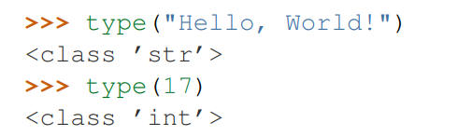
* In what cases, you will get ***SyntaxError*** from the compiler telling you that some of your variables have **invalid names**? Can you give 3 different examples of **invalid names**?

We get SyntaxError in some situations in which names beginning with an underscore have special meaning, or Python recognizes that is illegal name (invalid name).

3 different examples of invalid names:

2012doomday: the name starts with number

$$batman: to the name contains dollar signs (invalid character)

Import: Python keyword can not be used for variable’s name.

**Question 2:** Please kindly check the attachment of python file.

**Question 3:**

Sign up a [https://github.com](https://github.com/)  account:

Sign up under account: huuluannhan